STUDENT LESSON

A9 – Recursion
Student LESSON

A9 – Recursion

INTRODUCTION: Recursion is the process of a method calling itself as part of the solution to a problem. It is a problem solving technique that can turn long and difficult solutions into compact and elegant answers.

The key topics for this lesson are:

A. Recursion
B. Pitfalls of Recursion
C. Recursion Practice

VOCABULARY: BASE CASE RECURSION
STACK STACK OVERFLOW ERROR

DISCUSSION: A. Recursion

1. Recursion occurs when a method calls itself to solve another version of the same problem. With each recursive call, the problem becomes simpler and moves towards a base case. A base case is when the solution to the problem can be calculated without another recursive call.

2. Recursion involves the internal use of a stack. A stack is a data abstraction that works like this: New data is "pushed," or added to the top of the stack. When information is removed from the stack it is "popped," or removed from the top of the stack. The recursive calls of a method will be stored on a stack and manipulated in a similar manner.

3. The problem of computing factorials is our first example of recursion. The factorial operation in mathematics is illustrated below.

1! = 1
2! = 2 * 1 or 2 * 1!
3! = 3 * 2 * 1 or 3 * 2!
4! = 4 * 3 * 2 *1 or 4 * 3!

Notice that each successive line can be solved in terms of the previous line. For example, 4! is equivalent to

4 * 3!

A recursive method to solve the factorial problem is given below. Notice the recursive call in the last line of the method. The method calls another implementation of itself to solve a smaller version of the problem.

int fact(int n){
// returns the value of n!
// precondition: n >= 1
if (n == 1){
return 1;
}else{
return n * fact(n - 1);
}
}

4. The base case is a fundamental situation where no further problem solving is necessary. In the case of finding factorials, 1! is by definition 1. No further work is needed. Each recursive method must have at least one base case.

5. Suppose we call the method to solve fact(4). This will result in four calls of method fact.

fact(4): This is not the base case (1 == n), so we return the result of 4 * fact(3). This multiplication will not be carried out until an answer is found for fact(3). This leads to the second call of fact to solve fact(3).

fact(3): Again, this is not the base case and we return
3 * fact (2). This leads to another recursive call to solve fact(2).

fact(2): Still, this is not the base case, we solve 2 * fact(1).

fact(1): Finally we reach the base case, which returns the value 1.

6. When a recursive call is made, the current computation is temporarily suspended and placed on the stack with all its current information available for later use.

7. A completely new copy of the method is used to evaluate the recursive call. When that is completed, the value returned by the recursive call is used to complete the suspended computation. The suspended computation is removed from the stack and its work now proceeds.

8. When the base case is encountered, the recursion will now unwind and result in a final answer. The expressions below should be read from right to left.

fact(4) = 4 * fact(3) = 3 * fact(2) = 2 * fact(1) = 1

24 ← 4 * 6 ← 3 * 2 ← 2 * 1

Figure 9.1 below diagrams what happens:

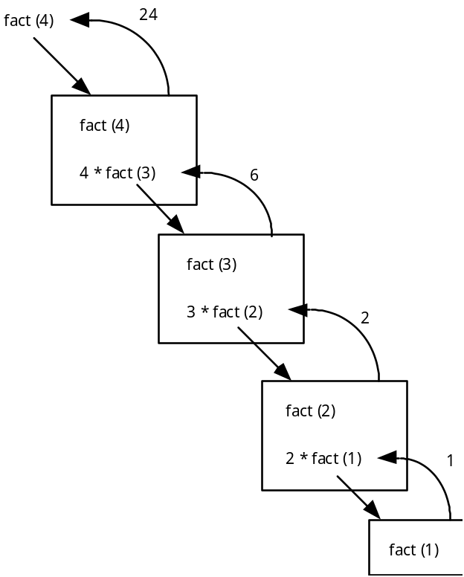
Figure 9.1 – Recursive Boxes

Each box represents a call of method fact. To solve fact(4) requires four calls of method fact.

9. Notice that when the recursive calls were made inside the else statement, the value fed to the recursive call was (n-1). This is where the problem is getting simpler with the eventual goal of solving 1!.

B. Pitfalls of Recursion

1. If the recursion never reaches a base case, the recursive calls will continue until the computer runs out of memory and the program crashes. Experienced programmers try to examine the remains of a crash. The message “stack overflow error” or “heap storage exhaustion” indicates a possible runaway recursion.

2. When programming recursively, you need to make sure that the algorithm is moving toward a base case. Each successive call of the algorithm must be solving a version of the problem that is closer to a base case.

C. Recursion Practice

1. To provide some practice, write a recursive power method that raises a base to some exponent, n. Use integers to keep things simple.

double power(int base, int n){
// Recursively determines base raised to
// the nth power. Assumes 0 <= n <= 10.

if ( n == 0)
return 1
else
base * power(base, n-1)

}

SUMMARY/ REVIEW: | Recursion takes some time and practice to get used to. Eventually, you want to be able to think recursively without the aid of props and handouts. Study the examples provided in these notes and work it through for yourself. Recursion is a very powerful programming tool for solving difficult problems.

ASSIGNMENT: Lab Assignment A9.1, Fibonacci
Lab Assignment A9.2, KochCurve
Worksheet A9.1, Recursion Review
Transparency A9.1, factorial

